Machine Learning Models and Techniques for Early Detection of Preeclampsia Risk: A Systematic and Bibliometric Review.

Karla Hidalgo ª, Deyvis Quispe ª, Joshua Pedraza ª, Nemias Saboya ª
ª Escuela Profesional de Ingeniería de Sistemas, Facultad de Ingenieria y Arquitectura, Universidad Peruana Unión, Lima, Peru

Abstract

One of the main factors of maternal and perinatal morbidity and mortality in the world is preeclampsia, which highlights the need for predictive tools that can be used from the early stages in clinical practice. In this framework, machine learning (ML) methods have been extensively studied to anticipate risk during pregnancy. However, applicability in the clinical setting is restricted due to poor external validation, a wide variety of methods, and low standardization of variables. This systematic and bibliometric review aimed to critically evaluate the ML models used for the early prediction of preeclampsia, analyzing their performance, methodological quality, and possibility of clinical implementation. In accordance with the PRISMA 2020 guidelines, a search was carried out in ScienceDirect, Scopus, PubMed, and Web of Science, which made it possible to include 47 studies published between 2016 and 2025. The conclusions show that tree-based models, such as XGBoost and Random Forest, are predominant and present high levels of performance. Support Vector Machine models are used mainly in small data sets, while neural networks have a higher potential in situations with large data volumes. However, repeated restrictions were found, such as a lack of external validation, a retrospective design, and an imbalance between classes. This could lead to an overestimation of performance. It is concluded that, despite the great predictive capacity of ML models, their use in medical practice is still scarce. To optimize its usefulness and generalization in clinical practice, multicenter research, standardized data, and robust validation methods are needed.

Keywords: Artificial Intelligence, Preeclampsia, machine learning, early prediction, predictive models, external validation.

1. Introduction

One of the most important hypertensive disorders in pregnancy is preeclampsia, which globally has a considerable effect on maternal and perinatal mortality and morbidity, covering about 3% to 8% of pregnancies [1]. Its early detection and the application of effective preventive tactics are hampered by its multifactorial nature and its pathophysiology, which is not yet fully clarified. This includes genetic predisposition, alterations in the placenta, endothelial dysfunction, and immunological factors. In many situations, the clinical onset is insidious and can progress rapidly to severe complications. This highlights the urgency of having predictive instruments that are accurate, timely, and reliable from a clinical point of view.

Machine learning (ML) techniques have been presented as an option that promises to improve the early detection of complex obstetric conditions in this situation. Machine learning (ML) models, unlike conventional statistical methodologies, enable the discovery of multidimensional relationships and non-linear patterns in large amounts of diverse data [2,3]. Risk stratification and support for clinical decision-making have shown high potential by integrating biochemical, clinical, and genomic data [4].

The use of supervised algorithms, such as Support Vector Machines (SVM) and Random Forest, to predict preeclampsia has been examined in multiple investigations [5,6]. Also, more current methods such as Extreme Gradient Boosting (XGBoost) have demonstrated great predictive performance in situations with greater structural complexity and data availability [3,7].

In addition, the use of electronic health records has made it possible to design longitudinal predictive models, which can model the progress of pregnancy over time and calculate the dynamic risk of preeclampsia [3,8]. In addition, the addition of hemodynamic and biochemical biomarkers, such as the sFlt-1/PlGF ratio or NT-proBNP, has shown that the accuracy of the diagnosis can be increased, and hybrid models that integrate molecular and clinical information can be strengthened [9]. Likewise, the identification of molecular signatures linked to the disease has been facilitated by advances in multi-omic analysis, which have provided opportunities for predictive modeling [4].

However, there continue to be important methodological limitations that limit the clinical applicability of the suggested models, despite the exponential increase in studies in this field. Some of the difficulties mentioned in different investigations [3,5,6] are the disparity of input variables, small sample sizes, and imbalance between classes; in addition, the lack of solid external validations [10,11] and the prevalence of retrospective designs. These restrictions can lead to an overestimation of the performance of the models and hinder their widespread application in various populations and clinical contexts.

Although the amount of research has been increasing, the existing systematic reviews have great deficiencies, since they focus more on descriptions of algorithms and performance metrics and less on a critical analysis of the methodological rigor, reproducibility, and clinical applicability of the models. Therefore, a significant gap between the creation of predictive models and their application in clinical practice continues to exist.

In this framework, the goal of this research is to carry out a systematic and critical review of the literature, in accordance with the PRISMA 2020 guidelines [12], with the purpose of analyzing the machine learning models used to predict the risk of suffering from preeclampsia early. This review aims to evaluate its methodological quality, validation strategies, properties of input data, and clinical applicability. It also aims to detect the most important limitations and suggest research approaches to create models that are more robust, generalizable, and applicable in a clinical setting.

2. Methodology

This analysis is a Systematic Literature Review (SRL) whose objective is to find, study, and summarize the scientific evidence related to the machine learning models and methods used to detect the risk of preeclampsia early.

The methodology was organized by combining two approaches that complemented each other. On the one hand, the guidelines suggested by Kitchenham et al. [13] were implemented, and subsequent studies that refine this methodology [14] were also used, which are widely used in systematic reviews within the field of software engineering and computer science. On the other hand, in accordance with the PRISMA 2020 statement [12], the process of identification, selection, eligibility, and inclusion of the studies was carried out, ensuring that each stage of the study was methodologically rigorous and transparent.

The review protocol was established previously, covering the preparation of the research questions, the search method, and the selection criteria. The Parsifal tool was used to plan and manage the process, which made it possible to organize the flow of study selection in a structured way, document decisions, and ensure methodological traceability.

In addition, a bibliometric analysis was carried out in the R environment [15], with the Bibliometrix tool, to determine the scientific structure of the field of study, examine research trends, study co-occurrence patterns of key terms, and analyze how the literature has evolved in thematic terms. This study was used as a complement to the qualitative synthesis and contributed to a more complete understanding of the current situation in the area.

2.1. Review Protocol (Planning)

2.1.1. Research questions

The research questions were formulated using the PICOC (Population, Intervention, Comparison, Results, and Context) framework [13], which is frequently used in systematic reviews to organize search strategies and research questions. Table 1 shows the PICOC framework.

From this framework, four Research Questions (RQ) were formulated that guided the processes of search, selection, extraction, and synthesis of information. These questions allow us to structure the analysis of the literature from both a descriptive and analytical perspective. The RQs are presented in Table 2.

Table 1
PICOC framework
Component | Description
P (Population) | Pregnant women who are at risk for preeclampsia.
I (Intervention) | Using machine learning methods or models to identify risk early.
C (Comparison) | Not applicable; it was not considered a comparator due to the observational nature of the studies.
O (Result) | Identification of algorithms used, input variables, performance metrics, and reported limitations.
C (Context) | Original studies published between 2016 and September 2025.

Table 2
Definition of research questions
Nº. | Research question | Objective
RQ1 | What machine learning models and Algorithms have been used in the early detection of preeclampsia risk? | Identify and characterize the most commonly used machine learning approaches and techniques, as well as their performance reported in the literature.
RQ2 | What types of input variables and data sources are used in machine learning models for the early prediction of preeclampsia? | Analyze the clinical, biochemical, imaging, or other variables used, as well as the provenance and nature of the data sets.
RQ3 | What performance metrics are reported in the analyzed studies? | Examine the indicators used to evaluate the models (AUC, sensitivity, specificity, accuracy, F1-score) and their application in different contexts.
RQ4 | What are the main limitations and methodological challenges reported in the literature? | Identify recurrent problems in the development and validation of models, such as sample size, class imbalance, lack of external validation, and interpretability.

2.1.2. Search strategy

The identification of studies was carried out through a systematic search in four high-impact databases: Scopus, PubMed, Web of Science, and ScienceDirect, selected for their broad coverage in biomedical and computational literature, which made it possible to recover interdisciplinary studies related to machine learning and preeclampsia.

The search strategy was designed using Boolean operators (AND, OR) and combinations of controlled and free terms, integrating synonyms related to machine learning and preeclampsia, in order to maximize the sensitivity and comprehensiveness of the search. Pilot searches were carried out in each database to refine the search strings and adjust the relevance of the terms used.

The time range included studies published between January 2016 and September 2025, in English or Spanish, and with full-text availability, in order to allow an adequate methodological evaluation and extraction of relevant information. The final search strings used in each database are presented in Table 3, tailored to the specific syntax of each platform.

After the recovery of the records, all the results were exported to the Parsifal platform, where the elimination of duplicates was carried out. Subsequently, the inclusion and exclusion criteria defined in the protocol were applied to obtain the final list of selected studies.

Table 3
Search strings and results by database
Database | Search string | Found articles
Scopus | TITLE-ABS-KEY: ("machine learning" OR "deep learning" OR "transfer learning" OR "artificial intelligence" OR "ml" OR "algorithm" OR "techniques" OR "predictive model") AND ("preeclampsia" OR "pre-eclampsia" OR "gestational hypertension" OR "pregnancy complication" OR "hypertensive disorder") AND ("early detection" OR "prediction" OR "risk assessment" OR "risk stratification" OR "prediction models") AND ("metrics" OR "biomarkers" OR "clinical data" OR "imaging" OR "validation" OR "interpretability" OR "class imbalance") | 445
PubMed | ("machine learning" OR "deep learning" OR "transfer learning" OR "artificial intelligence" OR "ml" OR "algorithm" OR "techniques" OR "predictive model") AND ("preeclampsia" OR "preeclampsia" OR "gestational hypertension" OR "pregnancy complication" OR "hypertensive disorder") AND ("early detection" OR "prediction" OR "risk assessment" OR "risk stratification") AND ("metrics" OR "biomarkers" OR "clinical data" OR "imaging" OR "validation" OR "interpretability" OR "class imbalance") | 315
Web of Science | "TS= (""machine learning"" OR ""ml"" OR ""algorithm"" OR ""techniques"" OR ""predictive model"") AND TS= (""preeclampsia"" OR ""gestational hypertension"" OR ""pregnancy complication"" OR ""hypertensive disorder"") AND TS= (""risk detection"" OR ""risk assessment"" OR ""prediction"" OR ""screening"") AND TS= (""data analysis"" OR ""statistical model"" OR ""feature selection"" OR ""classification"")" | 180
ScienceDirect | ("machine learning" OR "deep learning" OR "transfer learning" OR "artificial intelligence") AND ("preeclampsia" OR "pregnancy complication") AND ("early detection" OR "risk assessment") AND ("metrics") | 72

After the records were retrieved, all the results were exported to the Parsifal platform, where the duplicate entries were eliminated. Then, to obtain the definitive list of selected studies, the inclusion and exclusion parameters established in the protocol were used.

2.2. Study selection criteria (conducting)

2.2.1 Inclusion criteria (IC)

Following the guidelines of Kitchenham et al. [13], the inclusion criteria were defined in the protocol planning phase. In order to ensure that each decision made during the selection process is recorded in an orderly manner and that there is logical traceability from a methodological point of view, they were applied on the Parsifal platform.

Table 4 presents the inclusion criteria, in addition to their justification and description from a methodological perspective.

Table 4
Inclusion Criteria
Code | Criteria | Detailed Description | Justification / Contribution
IC1 | Articles written in English or Spanish | Research published in  Spanish or English. | It allows a rigorous evaluation of the content, ensuring an accurate interpretation in the predominant languages in the scientific literature.
IC2 | Original empirical research articles | Research that presents results based on verifiable quantitative data or experimental studies. | It increases the validity of the synthesis by ensuring that the data analyzed comes from empirically supported primary research.
IC3 | Articles published between 2016 and 2025 | Research carried out during the established period to capture recent advances in machine learning applied to health. | It makes it possible to show the state of the art, taking into account the recent progression of advanced deep learning and machine learning methods.
IC4 | Articles that are open access | Publications are included that have the document completely available and without restrictions, which allows transparent access to all the results and methodological data. | It allows independent verification, uniformity of access to all the evaluated text, and the ability to be reproduced.
IC5 | Full text availability | Research that has access to the entire content, that is, to the data, methodology, and results. | It makes it possible to carry out a meticulous analysis of the methodological quality and guarantees the adequate collection of data.
IC6 | Application of machine learning models in preeclampsia | Research that uses predictive models to detect or predict the risk of preeclampsia early. | Ensures the relevance of the topic and that it is aligned with the purpose of the review.
IC7 | Studies that report performance metrics | Research that shows quantitative parameters, such as sensitivity, specificity, AUC, accuracy, or F1-score. | It facilitates the analysis of the reported efficacy of the models and their usefulness in clinical situations.
IC8 | Study population: pregnant women | Research based on information obtained from pregnant women. | It ensures the clinical relevance and direct applicability of the models to the study context.

2.2.2 Exclusion Criteria (EC)

Those studies that did not meet one or more of the established inclusion criteria were excluded. The exclusion criteria were systematically applied during the screening and eligibility phases in the Parsifal platform, guaranteeing methodological consistency, traceability, and alignment with the review protocol. The exclusion criteria are presented in Table 5, along with their description and methodological justification.

Table 5
Exclusion criteria
Code | Criteria | Detailed Description | Justification / Contribution
EC1 | Articles published before 2016 | Studies published outside the defined time range. | It allows the review to focus on recent evidence, in line with contemporary advances in machine learning applied to health.
EC2 | Items that do not report performance metrics | Research that does not present quantitative indicators such as AUC, sensitivity, specificity, accuracy, or F1-score. | The absence of metrics prevents analysis of the reported performance of the models and limits the interpretation of their results.
EC3 | Articles without full text availability | Studies whose full content could not be retrieved. | It prevents a thorough evaluation of the methodology, verification of the results, and appropriate data extraction.
EC4 | Studies that do not apply machine learning models | Works based exclusively on traditional statistical methods or other approaches not related to ML. | They do not fit the primary purpose of  the review.
EC5 | Studies that do not focus on preeclampsia or gestational hypertension | Research focused on other unrelated pathologies. | Ensures that the subject of the research is examined.
EC6 | Methodological quality evaluation < 3.5 | Studies that do not meet minimum methodological quality criteria according to the evaluation tool used. | By excluding evidence with important methodological problems, the risk of bias in the synthesis is reduced.
EC7 | It is not an original empirical research article | It includes reviews, editorials, case reports, opinions, grey literature, blogs, columns, or documents without experimental evidence. | Ensuring the quality of the data used and scientific rigor avoids research that does not have a verifiable empirical design or that has not been peer-reviewed.
EC8 | Duplicate papers | Repeated articles that appear in multiple databases. | Avoid repeating information and guarantee the  uniqueness of the final set of investigations.

2.2.3. Selection process

The study identification and selection procedure were carried out in accordance with the PRISMA 2020 guidelines to ensure that each phase of the systematic review was reproducible, transparent, and traceable. Likewise, the methodological approach proposed by Kitchenham et al. [13]was incorporated, which is widely applied in systematic reviews in the field of software engineering. This made it possible to adjust the process to an interdisciplinary framework.

Initially, 1,012 records were collected from the chosen databases. Then, 155 duplicate records were deleted, and 857 studies were obtained for the screening stage. In this phase, filters were used linked to the time range (2016-2025), the language (Spanish and English), and the type of document (conferences and articles).

The full texts of the investigations were reviewed during the eligibility phase, and those that did not meet the established criteria were discarded. The main reasons for exclusion included: research that did not use machine learning techniques, work that did not focus on preeclampsia, lack of an empirical design, and other methodological restrictions detected during the analysis.

Subsequently, the remaining studies were subjected to a methodological quality evaluation, excluding those that did not reach the defined minimum threshold. Finally, 47 primary studies were included in the qualitative synthesis and bibliometric analysis.

The detailed results of the database selection process are presented in Table 7, while the overall procedure flow is shown in Fig. 1, prepared according to the PRISMA 2020 diagram. This diagram represents in a structured way the phases of identification, screening, eligibility, and inclusion of the studies, integrating Kitchenham's methodological approach in the organization of the review process.

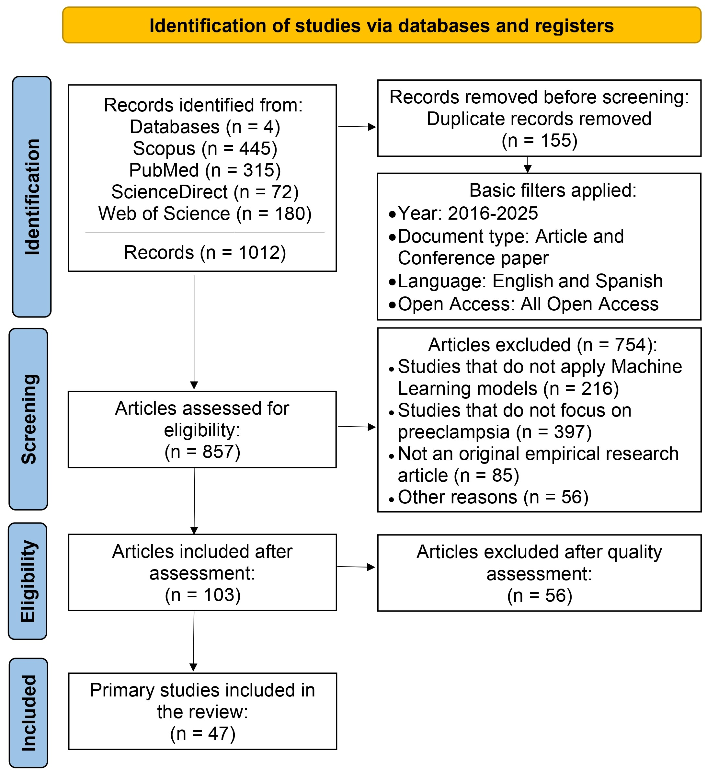
Fig. 1. PRISMA 2020 flow diagram adapted for the study selection process.

2.3. Quality Evaluation and Data Extraction

2.3.1. Quality Evaluation
The evaluation of the methodological quality was carried out through a checklist based on the guidelines of Kitchenham et al. [13], and was implemented in the Parsifal platform. This approach made it possible to assess the methodological rigor, the quality of the data, the clarity of the report, and the validity of the results of each study included.
The researchers conducted the assessment independently using Parsifal, which enables the systematic recording of grades and collaborative assessment. In situations where disagreements arose in the assignment of scores, they were resolved through dialogue and consensus. This procedure made it possible to reduce the bias in the evaluation and ensure that the quality criteria were applied consistently. In addition, a pilot evaluation stage was carried out with a subset of studies to adjust the criteria and ensure that the interpretation of the quality items was uniform. Table 6 shows the quality assessment (QA) questions.

Table 6
Quality assessment questions
Nº. | Quality evaluation | Reason
QA1 | Does the article clearly describe the machine learning models or algorithms used? | It allows for ensuring the methodological transparency and the reproducibility of the approach.
QA2 | Does the article detail the input variables and dataset used? | It allows evaluating the quality, relevance, and traceability of the data used.
QA3 | Does the article report relevant performance metrics (AUC, sensitivity, specificity, accuracy, F1-score)? | It allows for the analysis of the reported performance of the models and their applicability in clinical contexts.
QA4 | Does the study analyze the limitations or methodological challenges of the model? | Reflects scientific rigor and the identification of possible biases.
QA5 | Does the study clearly describe the validation method used? | It allows evaluating the generalizability of the model and the control of overfitting.
QA6 | Does the article report the management of class imbalance? | It allows evaluating the robustness of the model in real clinical contexts.

Each study was evaluated using an ordinal scale, assigning 1 point to complete responses, 0.5 to partial responses, and 0 to the absence of evidence. The maximum score was 6.0 points.

Since the checklist consisted of six quality assessment items, a threshold of ≥ 3.5 points (more than half of the maximum score) was established to identify studies that met the minimum methodological quality required for inclusion. Studies that did not reach this threshold were excluded from the final synthesis.

Table 7
Results of the selection process and quality evaluation by the database.
Database | Records identified | Duplicates deleted | Exclusion criteria evaluation | Quality evaluation | Total Removed | Total Included
Scopus | 445 | 45 | 348 | 33 | 426 | 19
PubMed | 315 | 81 | 212 | 15 | 308 | 7
Web of Science | 180 | 22 | 131 | 8 | 161 | 19
ScienceDirect | 72 | 7 | 63 | 0 | 70 | 2
Total | 1.012 | 155 | 754 | 56 | 965 | 47

2.3.2. Data Extraction

A data extraction matrix was developed on the Parsifal platform to ensure that data is extracted in a systematic, homogeneous, and traceable manner. This matrix enabled the structured organization of the essential components reported in each study, ensuring their direct alignment with the research questions (RQ1-RQ4) established in the protocol. Table 8 shows the categories that are taken into account when extracting data.

Table 8
Data Extraction Matrix
Code | Category / Item | Description | Objective
DE1 | Machine learning Model or Algorithm | Techniques used for early prediction of preeclampsia risk. | It allows us to identify the predominant computational approaches and respond to RQ1.
DE2 | Type of data or input variables | Clinical, biochemical, or imaging characteristics are used as predictors. | It allows us to analyze the relevant variables used in the models and respond to RQ2.
DE3 | Source and size of the dataset | Origin of the data (cohorts, clinical databases, repositories) and sample size. | It allows evaluating the strength, representativeness, and quality of the data used in the studies.
DE4 | Performance metrics | Indicators used to evaluate the models (AUC, sensitivity, specificity, accuracy, F1-score). | It allows us to analyze the reported performance of the models and respond to RQ3.
DE5 | Methodological Limitations | Restrictions or problems reported in the studies. | It allows us to identify recurrent weaknesses in the literature and respond to RQ4.
DE6 | Recommendations or future directions | Proposals to improve the models and their clinical applicability. | It allows you to identify future research opportunities and strengthen the discussion.

The extraction matrix allowed the information to be integrated in a consistent and structured way, facilitating the analysis of the machine learning models, the variables used, the quality of the datasets, the reported performance, and the methodological limitations. These elements served as a basis for the qualitative synthesis and bibliometric analysis, as well as to systematically respond to each of the research questions raised in this review.

2.4. Analysis and Synthesis of Data (Reporting)

2.4.1. Data synthesis

The synthesis of the information was developed through a qualitative approach of a narrative and analytical type, aimed at answering the research questions (RQ1-RQ4) and integrating the findings from the 47 included studies. A quantitative meta-analysis could not be carried out due to the diversity of methods observed between the investigations, regarding the variables used, the models used, the sample size, and the evaluation metrics. An analytical and thematic synthesis was used instead, which made it possible to recognize repeated patterns, nascent trends, and major limitations in the literature.

Fig. 2 shows the sequence between the quality assessment (QA) items, the research questions (RQ), and the components for data extraction (DE). This scheme shows the traceability of the methodological process, revealing how each research question guides the quality evaluation and the collection of relevant information.

In this context, the elements used for data extraction (DE) were defined in a manner consistent with the research questions, which made it possible to organize the literary analysis and ensure that the results systematically meet the established objectives. This integration ensures internal consistency, transparency in methods, and consistency between review stages.

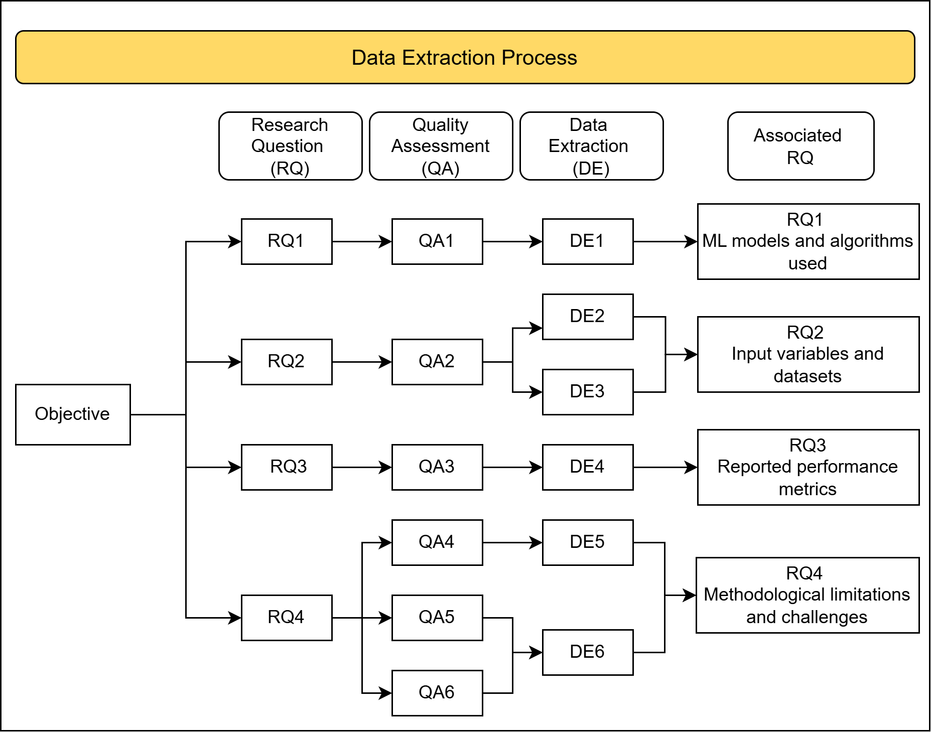
Fig. 2. Data Extraction Process Flow

2.4.2. Bibliometric analysis

In order to describe the conceptual structure of the field of study and add to the qualitative synthesis, a bibliometric analysis was carried out in the R environment with the Bibliometrix package and its Biblioshiny interface [15]. The identification of research patterns, connections between concepts, and the development of the main thematic lines was possible thanks to this analysis, which used the co-word analysis technique, thematic mapping, and conceptual structure analysis.

The analysis was carried out using the records obtained from the Web of Science and Scopus databases, due to their high coverage in terms of indexed scientific literature and their importance for interdisciplinary research on machine learning and health. To ensure the consistency of the analysis, the data was cleaned before, normalizing the metadata and eliminating duplicates, which guaranteed the quality and integrity of all the information. The results of the bibliometric analysis made it possible to identify consolidated areas of study, emerging trends, and thematic clusters. In this way, a structured and quantitative perspective of the progress of the field was obtained, which also served as a complement to frame the findings of the systematic review.

2.4.2.1. Thematic analysis

The analysis, carried out with Biblioshiny, constructed a thematic map that classifies the themes according to two dimensions: (i) centrality, which reflects the relevance of the theme in the structure of the field, and (ii) density, which indicates its degree of development or maturity.

Fig. 3 shows the distribution of topics in the four classical quadrants:

- Motor themes: terms such as machine learning, risk factor, and receiver operating characteristic are identified, which present high levels of centrality and density. This indicates that they are well-developed and fundamental lines of research in the field, evidencing the consolidation of the use of machine learning techniques in predicting the risk of preeclampsia.

- Basic topics: terms such as preeclampsia and biological markers are grouped, which, although they are highly relevant, show a lower degree of development. This finding suggests that, although biomarkers and the clinical study of the disease form the basis of the field, their integration with advanced analytical approaches is still limited.

- Specialized or niche topics: represented by terms such as algorithm, procedures, and metabolism, they show a high level of development but low centrality, indicating that they correspond to specific lines of research with less impact on the general structure of the field.

- Emerging or declining topics: terms related to the study population are located, such as human, female, and pregnancy, suggesting a transition from traditional descriptive approaches to more analytical methodologies based on data.

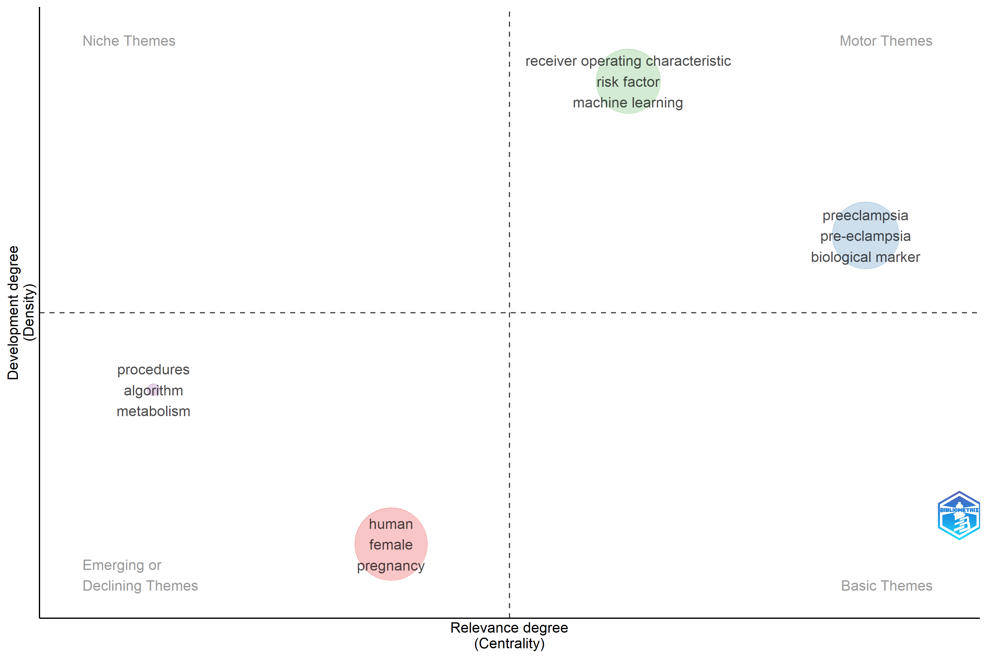
Fig. 3. Thematic map of density and centrality

These results show an evolution of the field towards approaches focused on machine learning, although there is still limited integration between clinical foundations and advanced predictive models.

2.4.2.2. Co-occurrence network

Fig. 4 presents the keyword co-occurrence network, which identifies well-defined clusters that reflect the conceptual structure of the field. The blue cluster brings together important terms such as preeclampsia, pregnancy, humans, and biological markers, highlighting a mainly clinical perspective focused on investigating the disease and its biomedical traits. This cluster is the center of the field, suggesting that research continues to focus intensively on the clinical understanding of preeclampsia.

The red cluster, on the other hand, is related to terms such as "receiver operating characteristic", "prediction", "risk factor," and "clinical study". This indicates using predictive models and machine learning techniques to assess risk. However, this cluster is partially disconnected from the clinical core, indicating reduced integration between conventional biomedical research and computational methods. In addition, there is a smaller cluster associated with terms such as newborn and infant, which indicates a secondary line of research with less relative development.

Overall, these findings show that, although the use of machine learning has gained importance in the early prediction of preeclampsia, there is still an important difference between the methodological development of predictive models and their effective integration with biomarkers and clinical data.

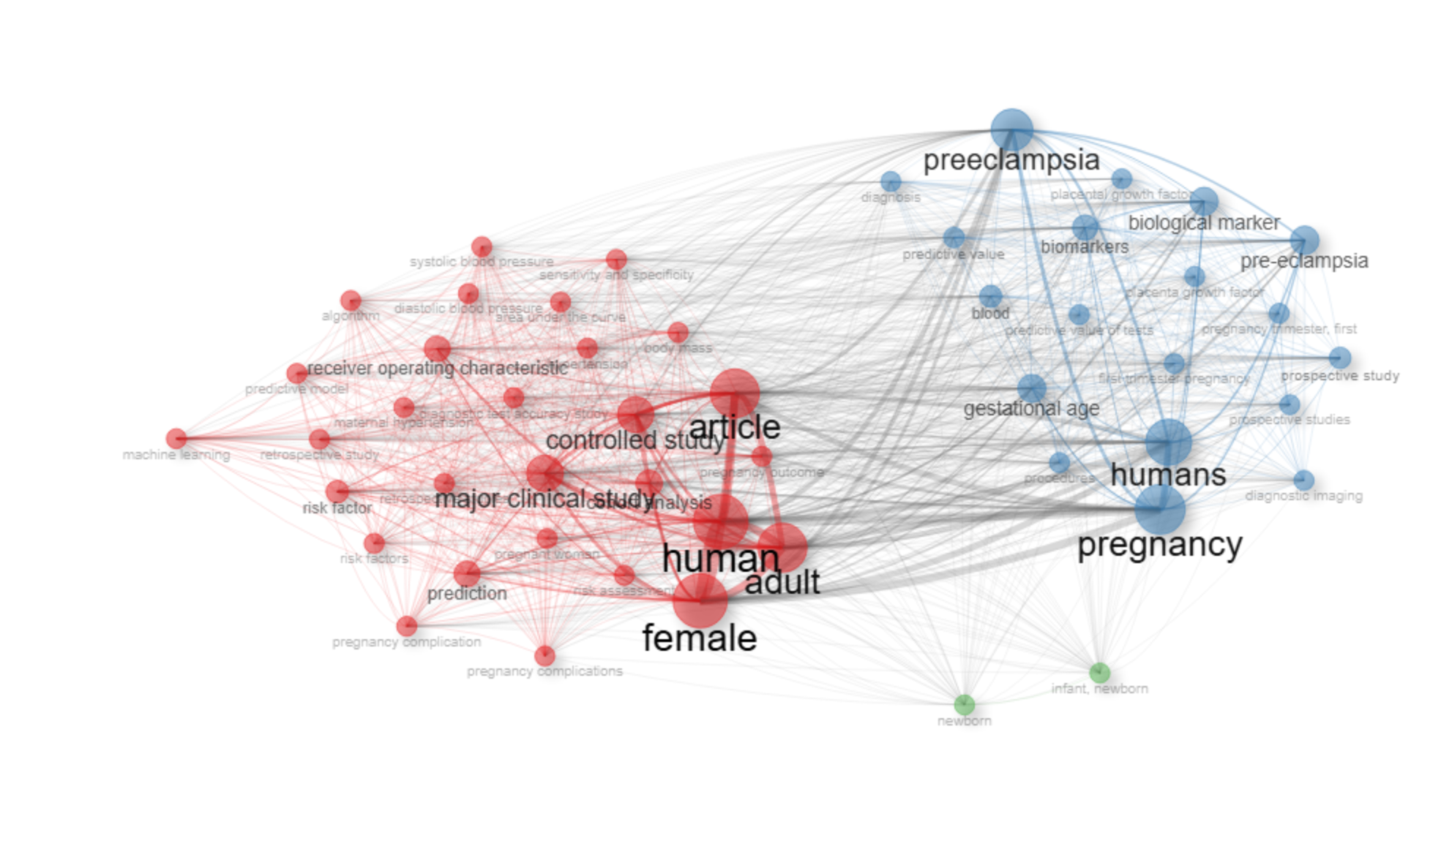
Fig. 4. Co-occurrence network

2.4.2.3. Global map of collaboration between countries

Fig. 5 illustrates the global map of collaboration between countries in the field of machine learning for preeclampsia prediction. The map also reflects the geographical distribution of scientific production, where darker shades indicate higher research output, while connecting lines represent international research collaborations between countries. The United States and China exhibit both the highest scientific production and the strongest collaborative activity. Significant contributions are also observed in Europe and Australia, whereas Latin America and Africa remain comparatively underrepresented. This distribution suggests geographical disparities in scientific production, which may be associated with differences in research capacity, access to advanced technologies, and the availability of clinical data.

From a methodological perspective, this geographical concentration indicates that most machine learning models have been developed and validated within specific populations and healthcare environments, which may limit their generalizability and applicability across diverse clinical settings.

These findings highlight the importance of promoting multicenter and geographically diverse research that integrates data from underrepresented regions to develop more robust, equitable, and clinically transferable predictive models for the early prediction of preeclampsia.

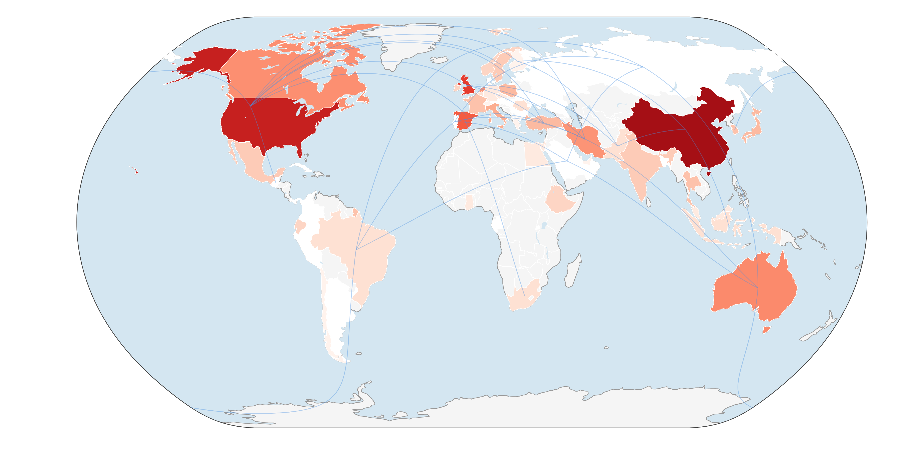
Fig. 5. Global map of collaboration between countries

3. Results

This section shows the main results obtained from the systematic review, which include the analysis of its distribution, methodological quality, and concordance with the research questions established in Table 2, as well as the characterization of the selected studies.

3.1. General characterization of the included studies

After removing duplicate records, applying the inclusion and exclusion criteria, and completing the methodological quality assessment, 47 studies were included in the final review from a total of 1,012 records retrieved from the selected bibliographic databases. The distribution of retrieved records across the bibliographic databases showed that Scopus contributed the largest proportion (44.0%), followed by PubMed (31.1%), Web of Science (17.8%), and ScienceDirect (7.1%) (Fig. 6). The higher proportion of records retrieved from Scopus is consistent with its broad coverage of biomedical and engineering literature.
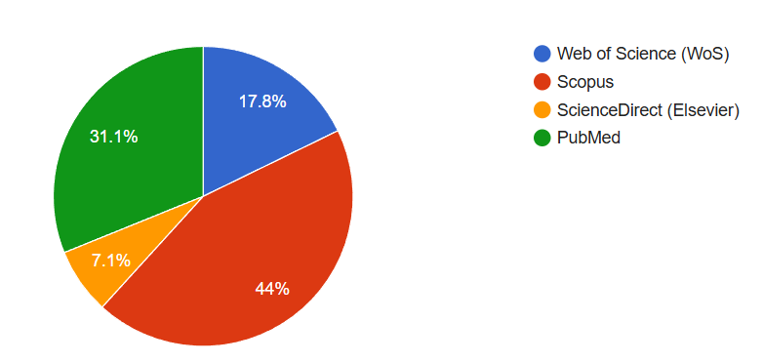
Fig. 6. Percentage distribution of results by database.

However, when comparing the records initially identified with the studies finally included (Fig. 7), a substantial reduction is observed after applying the predefined eligibility and methodological quality criteria. Specifically, although Scopus provided the highest initial number (n=445), only a small portion of these studies met the defined quality criteria, resulting in 19 articles included.

Web of Science and PubMed, which had lower numbers of initial records (n=180 and n=315, respectively), showed different inclusion rates after the application of the predefined selection criteria; Web of Science contributed 19 articles, matching Scopus, whereas PubMed contributed 7 included studies. In comparison, ScienceDirect contributed only two studies to the final set, demonstrating a lower overall contribution in terms of volume for the subject studied.

In summary, these findings indicate that, despite the large number of published studies, a considerable proportion did not meet the predefined eligibility and methodological quality criteria established for this review. These findings highlight the need to improve methodological quality, reporting transparency, and standardization in the development of machine learning models for preeclampsia prediction.

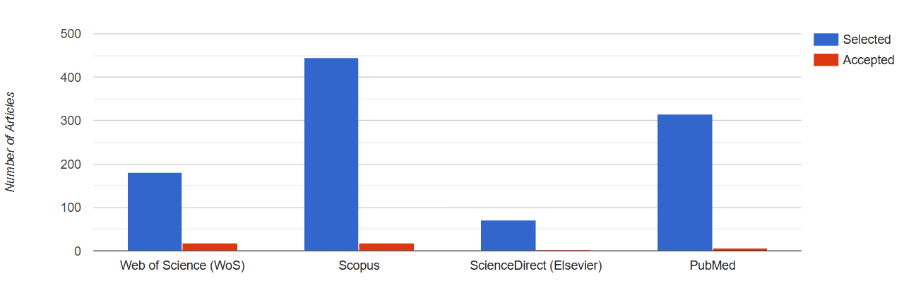
Fig. 7. Identified (blue) vs. accepted (red) items by data source.

3.2. RQ1: What Machine Learning Models and Algorithms have been used in the early detection of preeclampsia risk?

As can be seen in Table 9, the examination of the 47 studies that are part of this systematic review reveals a wide variety of algorithmic machine learning methods used to predict preeclampsia in early stages. However, there is an evident mastery of models based on assembly methods, followed by linear ones, vector support machines, and neural networks. This reflects a mixture of perspectives focused on both predictive ability and interpretability from a clinical point of view.

Table 9
Most commonly used Machine Learning Algorithms
Algorithms | Frequency  (%) | Description | Articles
Tree-based ensemble models (RF, XGBoost, GBM, AdaBoost, Stacking) | 66.0% | Predominant models in the literature are highly robust against heterogeneous and non-linear clinical data, with high predictive performance. | [7,8,16–21]
Linear models (Logistic Regression, LASSO, Elastic Net) | 59.6% | Widely used as base models for their clinical interpretability and ease of implementation. | [3,5,7,10,19,22–25]
SVM (Support Vector Machine) | 42.6% | Frequently used in datasets of moderate size and high dimensionality. | [7,19,26–29]
Neural networks (ANN, DNN, CNN, LSTM) | 29.8% | Used in scenarios with complex or multimodal data, especially biomarkers and images. | [4,30–34]
Other Models (KNN, Naïve Bayes, Fuzzy Logic, clustering) | 25.5% | Complementary approaches are used mainly for comparative or exploratory purposes. | [27,35–38]

Tree-based ensemble models, especially Random Forest and XGBoost, are the most widely used methods in the literature, as demonstrated by the results. This predominance can be explained by its ability to treat diverse clinical data, its strength against class imbalance (which is common in medical datasets), and its high predictive performance, with many studies reporting AUC values greater than 0.85.

Secondly, linear models, in particular logistic regression and its regularized versions (Elastic Net and LASSO), are frequently used. The main reason is their high interpretability in clinical contexts, where the explanation of the model and the identification of risk factors are essential to make medical decisions.

Support Vector Machines (SVMs), on the other hand, are frequently used in research that uses moderately large data sets with high dimensionality, evidencing an optimal balance between generalizability and predictive performance. However, its performance is strongly conditioned by the kernel used and by the choice of hyperparameters, which can restrict its applicability in more complex situations.

Deep learning methods and neural networks, although not as common, have shown great potential when it comes to integrating multimodal data, such as medical images, molecular biomarkers, or physiological signals. However, its application is still restricted due to poor interpretability and the fact that large volumes of data are required for its training.

Finally, other models, such as k-NN, Naïve Bayes, and approaches based on fuzzy logic or grouping, are mainly used as comparative or exploratory methods. This shows that they have less importance in terms of predictive performance compared to more sophisticated models. This discovery shows the importance of generating models that not only optimize predictive performance but also ensure interpretability, generalization, and applicability in the clinical setting.

3.3. RQ2: What are the input variables and data sets used by Machine Learning models?

Table 10 reveals that there is great diversity in the data used to predict preeclampsia, according to the studies examined. However, clinical and obstetric variables (72%), such as blood pressure, BMI, and age, are the predominant type of input data because of their availability and because they are used regularly in medical practice.

Biochemical biomarkers were used in 27% of the studies and were frequently incorporated to improve predictive performance, particularly angiogenic biomarkers such as PlGF and sFlt-1, although their use was less common than clinical and obstetric variables. Similarly, transcriptomic and genetic data (25%) have shown considerable predictive potential; however, their complexity limits their use.

The choice of machine learning technique was closely associated with the type of input data used, as shown in the use of image data (12%) combined with deep learning models. In turn, multimodal approaches (10%) represent an emerging trend aimed at improving predictive performance through the integration of multiple data sources.

In general terms, the results show that most of the models are still based on traditional clinical variables and that they incorporate advanced data in a limited way. These findings highlight a significant gap between the potential of machine learning techniques and their effective implementation in real clinical settings, particularly regarding data standardization and the availability of multimodal information.

Table 10
Types of input variables used
Type of data | Frequency  (%) | Description | Articles
Clinical and obstetric variables | 72% | Age, BMI, blood pressure, and obstetric history constitute the main basis of predictive models. | [3,10,19,20,24,25,39–41]
Biochemical biomarkers | 27% | Angiogenic (sFlt-1, PlGF), metabolic (uric acid, creatinine), and inflammatory (CRP, IL-6) markers. | [9,23,26,33,40,42]
Genetic/transcriptomic data | 25% | Placental gene expression, cfRNA, and co-expression network analysis (WGCNA). | [16,21,29,30,34,43–45]
Medical Image Data | 12% | Obstetric ultrasound and physiological signals are analyzed by CNN or LSTM. | [31,32,46]
Multimodal data (source integration) | 10% | A combination of clinical, omic, and biochemical data for hybrid models with greater capacity for generalization. | [4,21,27,33,47]

3.4. RQ3: What performance metrics are reported in the analyzed studies?

The studies included in this systematic review reported a variety of performance metrics used to evaluate machine learning models for the early prediction of preeclampsia, as shown in Table 11. The most frequently reported metrics correspond to binary classification measures, with the area under the receiver operating characteristic curve (AUC) being the most commonly reported, followed by sensitivity, specificity, accuracy, and F1-score.

Table 11
Reported performance metrics
Metrics | Performance range | Description | Articles
AUC / ROC Curve | 0.80 – 0.95 | The most commonly used indicator to evaluate the global discrimination of the model. | [5,7,10,17,23,39,41,48,49]
Sensitivity (Recall) | 0.70 – 0.92 | Measures the proportion of correctly identified positive cases. | [7,10,23,39,48]
Specificity | 0.73 – 0.93 | Determines the proportion of correctly classified negative cases. | [7,10,23,39,48]
Accuracy | 0.75 – 0.90 | Global measure of model performance, especially useful in balanced data. | [5,7,17,23,49]
F1-score | 0.70 – 0.88 | Harmonic average between accuracy and sensitivity; useful for unbalanced classes. | [7,17,18,48]
Other metrics (PR-AUC, Brier Score, Balanced Accuracy) | (0.65 – 0.90) | Reported in studies with deep learning or explainable models. | [4,18,21,50]

The results show that the AUC (Area Under the ROC Curve) is the predominant metric used to evaluate machine learning models for preeclampsia prediction. Its widespread use is explained by its ability to assess the overall discriminative performance of a model independently of a specific classification threshold, making it the standard evaluation metric in most medical prediction studies.

However, the widespread use of AUC also has limitations. In class-imbalanced datasets, such as those used for preeclampsia prediction, AUC may overestimate the practical performance of a model because it does not fully reflect its ability to correctly identify the minority class. Consequently, complementary metrics such as sensitivity and F1-score are particularly valuable for assessing the effectiveness of models in detecting positive cases.

Early identification of women at risk of preeclampsia is essential to reduce maternal and perinatal complications; therefore, sensitivity represents a particularly important performance indicator in this clinical context. Nevertheless, sensitivity should always be interpreted together with specificity, since increasing sensitivity alone may lead to a higher number of false-positive predictions.

Although accuracy was frequently reported in the analyzed studies, it is less informative when evaluating class-imbalanced datasets because high overall accuracy may mask poor performance in identifying positive cases. Likewise, the F1-score was reported less frequently, despite providing a more balanced evaluation by simultaneously considering Precision and Recall. Overall, ensemble-based models, particularly Random Forest and XGBoost, generally achieved the highest AUC values, which is consistent with the findings reported in RQ1.

Overall, these findings highlight the need for more comprehensive evaluation frameworks incorporating multiple complementary performance metrics rather than relying solely on AUC. Such evaluation strategies would improve the interpretability, robustness, and clinical applicability of machine learning models for the early prediction of preeclampsia, particularly in the presence of class imbalance.

3.5. RQ4: What are the main limitations and challenges reported in the literature?

The research shows that there are frequent methodological limitations that limit the clinical applicability of machine learning models to predict preeclampsia early.

First, the quality and representativeness of the data continue to be problematic, such as the small size of the samples, the imbalance between classes, and the lack of diversity in the population. These factors restrict the ability to generalize the models. Second, more sophisticated models, particularly those that are grounded in multimodal and deep learning approaches, have problems with interpretability. This makes it difficult to implement in clinical settings due to its "black box" nature.

In addition, the absence of external and multicenter validations represents one of the greatest limitations in methodological terms, because only a low percentage of studies report this type of evaluation, which puts at risk the strength and ability to reproduce the results. These restrictions manifest themselves differently according to the type of model (Table 12): linear models have limitations in the treatment of non-linear relationships, assemblies face difficulties with overfitting, and neural networks are not interpretable. Similarly, multimodal and omics-based approaches, while promising, are constrained by the scarcity of standardized datasets and complexity in data integration.

Table 12
Methodological Limitations and Challenges
Model or type of algorithm | Limitations | Challenges
Logistic regression/linear models | High dependence on variable selection; poor performance against complex non-linear relationships; sensitivity to collinearity [3,7,18,19,23–25] | Incorporate regularization (L1/L2) and automatic variable selection techniques; combine with non-linear methods to improve discrimination.
Decision trees and assembly methods (Random Forest, XGBoost) | Possible overfitting in small samples; may be affected by class imbalance if correction strategies are not applied; limited external validation in several studies [7,8,18,20,21,27,39,48,51] | Perform multicenter validations; apply cross-validation and balancing techniques (SMOTE, ADASYN); prioritize clinical interpretability (e.g., SHAP, permutation importance).
Vector Support Machines (SVMs) | High sensitivity to variable scaling; complexity in kernel selection; difficult to interpret [7,21,23,26,51] | Implement SVM with kernel optimized by Bayesian search or other hyperparameter optimization techniques; combine with explainable models (SHAP, LIME).
Neural networks (ANN, CNN, LSTM) | “Black box”: lack of clinical interpretability; high computational cost; risk of overfitting [4,30–32,46] | Incorporate explainability modules (XAI); integrate multimodal data (images, EHR, biochemical); improve generalization with dropout and transfer learning.
Hybrid and multimodal models (clinical + omics + biochemical) | Heterogeneous data integration; shortage of standardized multimodal datasets; training complexity [4,21,27,33,47] | Foster interoperable open databases; use Federated Learning to protect privacy and increase population diversity.
Models based on omics data (transcriptomics, proteomics, cfRNA) | Small sample size; lack of cross-validation; experimental noise in genetic data [16,29,34,43–45] | Validate models in independent cohorts; use dimensionality reduction (PCA, LASSO) and biological selection of relevant genes.
Image models (ultrasound, retina, digital placenta) | High inter-instrumental and inter-observer variability; lack of image standardization; dependence on manual annotations [30,31,46] | Promote the use of transfer learning with pre-trained networks; develop annotated public datasets with uniform clinical criteria.

Together, the results show that, despite advances in predictive performance, the transition of these models to clinical practice remains limited. This gap is mainly due to the lack of external validation, the poor interpretability of complex models, and the absence of standardization in the data. In this context, the literature highlights the need to develop more interpretable models, validate the results in multicenter cohorts, and promote the use of open and interoperable data. In addition, methodologies such as federated learning and explainability techniques (XAI) emerge as fundamental methods to overcome these restrictions and make their implementation easier in real clinical contexts.

4. Discussion

Based on the findings of this review, the use of machine learning (ML) to detect preeclampsia in early stages has grown considerably. However, this progress has been uneven, and the clinical implementation of these models remains limited due to insufficient external validation and limited integration into routine clinical practice.

4.1. General summary and contributions of the findings

The models based on decision trees and ensembles, especially Random Forest and XGBoost, remain the most widely used algorithms [7,21], since they can manage diverse clinical data, non-linear relationships, and imbalance between classes. This predominance reflects a preference for models that are both robust and relatively interpretable in clinical settings.

In addition, the inclusion of multimodal models and deep neural networks (CNN, LSTM) [4,30–32] represents an advance towards methods that can handle complex data, such as omics variables and medical images, achieving high levels of performance (average AUC between 0.80 and 0.95). However, their adoption remains limited compared with more traditional models.

Regarding the variables, the models continue to be based mainly on obstetric and clinical information [3,10,19,24]; the inclusion of genomic data and biomarkers is still in an initial phase. This shows that, although considerable progress has been noted in terms of methodology, the incorporation of advanced biological information in predictive models continues to be scarce.

An important discovery is that there is still a difference between the advancement of the methodology in machine learning models and their real integration with clinical data and biomarkers. Although ensemble-based models predominate in terms of performance and use, most of the research continues to be based on traditional variables. This indicates that technical progress does not always imply a significant improvement in terms of clinical applicability [10,39,41,48].

4.2. Comparison with previous research

This review covers a broader spectrum at the temporal and thematic level by incorporating recent research and several data sources, which allows a more complete perspective of the field, compared to previous studies and individual reports. This review, unlike many studies that have focused on specific algorithms or specific types of data, provides a comprehensive synthesis ranging from linear models to deep learning methods.

The findings are consistent with recent evidence indicating that the most effective models in terms of prediction are not always the most appropriate for clinical practice, since elements such as interpretability, external validation, and reproducibility are crucial for their implementation in hospital contexts [10,39,41,48].

Unlike previous reviews that primarily focused on comparing predictive performance across machine learning algorithms, the present review integrates methodological quality assessment, bibliometric analysis, model interpretability, external validation, and clinical applicability. This broader perspective enables the identification of methodological gaps and emerging research trends, providing a more comprehensive understanding of the current state of machine learning for early preeclampsia prediction.

4.3. Methodological limitations

Methodological disparity is not the only restriction that has been detected; there is also a lack of standardization in validation protocols, metrics, and variables. This hinders studies from being comparable and reproducible [12,13].

In addition, there continue to be problems associated with the representativeness and quality of the data, such as an imbalance in classes, little population variety, and small sample sizes. In addition, the scarce implementation of multicenter and external validations limits the generalization of the models [10,39].

In addition, more sophisticated models, particularly those that are grounded in deep learning, have difficulties with interpretability. This means that they cannot be applied in clinical settings due to their "black box" nature [30–32].

Another important limitation identified in this review is the limited generalizability of many published models. Most studies were developed using single-center datasets collected from specific populations, which may reduce model performance when applied to different healthcare systems or demographic groups. Future studies should prioritize multicenter collaborations and geographically diverse datasets to improve model robustness and external validity.

4.4. Implications for research and clinics

The findings indicate that machine learning has great potential to change prenatal screening through the earliest and most personalized prediction of preeclampsia risk [3,4,21]. However, its application in the clinical field requires overcoming obstacles related to data interoperability, external validation, and model interpretation.

The standardization of variables and evaluation metrics, the development of explainable AI (XAI), and the integration of multimodal data should be considered research priorities. In addition, to optimize equity and generalization in artificial intelligence applied to maternal health, strategies such as federated learning and the establishment of open and multicenter databases emerge as fundamental methods.

An additional challenge identified across the reviewed studies is the limited incorporation of explainable artificial intelligence (XAI) techniques. Although ensemble and deep learning models achieved the highest predictive performance, their limited interpretability remains a major barrier to clinical adoption. Future research should integrate explainability methods such as SHAP, LIME, and counterfactual explanations to improve clinicians' trust and facilitate decision-making in real-world healthcare environments.

4.5. Contributions of this review

This review presents an updated and comprehensive summary of the state of the art in the use of machine learning to predict early preeclampsia [3,4,7,21]. It shows not only the methodological progress achieved, but also the structural limitations that prevent its clinical application. In particular, critical gaps corresponding to data integration, external validation, and the ability to interpret models are recognized. This provides a firm foundation to guide further research into the design of more resilient solutions, which can be replicated and applied in clinical environments.

Finally, although machine learning has shown great potential in this area, its clinical implementation is still in an intermediate stage, where there are important technological advances along with structural restrictions that need to be overcome. To advance towards tools that are truly applicable in medical practice, future research must focus on validating models in multicenter cohorts, integrating multimodal data, and developing interpretable models.

5. Conclusions

This systematic review provides an updated overview of the current use of machine learning for the early prediction of preeclampsia, demonstrating significant progress in the development of predictive models and their ability to handle complex medical data. A clear trend toward the use of ensemble-based models is observed, together with an increasing adoption of deep learning approaches for multimodal applications.

Despite these advances, most studies continue to rely primarily on conventional clinical and obstetric variables, while the integration of advanced data sources, such as biomarkers, omics data, and medical imaging, remains limited. Consequently, a persistent gap exists between the technical performance of machine learning models and their effective translation into routine clinical practice. This gap is mainly driven by limitations related to data quality and representativeness, insufficient external validation, and the limited interpretability of complex models.

By integrating a systematic review methodology with bibliometric analysis, this study provides a comprehensive overview of current evidence while identifying the principal methodological gaps and emerging research trends in the field. Overall, the findings indicate that machine learning for early preeclampsia prediction is entering a phase of methodological consolidation, in which future progress will depend on the development of more robust, interpretable, externally validated, and clinically generalizable models.

This review provides a structured synthesis of current evidence, highlights the main methodological challenges, and identifies future research directions for the development of clinically applicable predictive tools. Future research should prioritize multicenter validation, standardized datasets, multimodal data integration, explainable artificial intelligence (XAI), and interoperable data infrastructures to facilitate the successful translation of machine learning models into routine clinical practice and ultimately improve maternal and perinatal health outcomes.

CRediT authorship contribution statement

Karla Hidalgo: Conceptualization, Methodology, Supervision, Writing – review and editing. Deyvis Quispe: Methodology, Writing – original draft, Writing – review and edition. Joshua Pedraza: Formal Analysis, Methodology, Writing – review and editing. Nemias Saboya: Validation, Formal Analysis, Writing – review and editing.

Conflicts of Interest Statement

The authors state that they have no financial or personal conflicts of interest that could have had an impact on the work presented in this study.

Ethics Statement

This research is a systematic review of previously published literature, so it did not involve intervention in human individuals or the use of identifiable data. Therefore, it did not need the approval of an ethics committee. The norms of scientific honesty and the correct citation of sources were honored.

Use of AI tools Statement

To improve the wording and clarity of the text, the authors employed artificial intelligence tools (ChatGPT) when creating this document. The writers reviewed and modified the content that was generated and took full responsibility for the accuracy, completeness, and originality of the manuscript.
Funding
This research received no specific funding.

Acknowledgement

The authors thank their academic advisors for their appreciated advice and observations during the research process.

References

[1] World Health Organization. Pre-eclampsia 2025. https://www.who.int/news-room/fact-sheets/detail/pre-eclampsia (accessed June 27, 2026).
[2] Marić I, Tsur A, Aghaeepour N, Montanari A, Stevenson DK, Shaw GM, et al. Early prediction of preeclampsia via machine learning. Am J Obstet Gynecol MFM 2020;2. https://doi.org/10.1016/j.ajogmf.2020.100100.
[3] Li S, Wang Z, Vieira LA, Zheutlin AB, Ru B, Schadt E, et al. Improving preeclampsia risk prediction by modeling pregnancy trajectories from routinely collected electronic medical record data. NPJ Digit Med 2022;5. https://doi.org/10.1038/s41746-022-00612-x.
[4] Marić I, Contrepois K, Moufarrej MN, Stelzer IA, Feyaerts D, Han X, et al. Early prediction and longitudinal modeling of preeclampsia from multiomics. Patterns 2022;3. https://doi.org/10.1016/j.patter.2022.100655.
[5] Jhee JH, Lee S, Park Y, Lee SE, Kim YA, Kang SW, et al. Prediction model development of late-onset preeclampsia using machine learning-based methods. PLoS One 2019;14. https://doi.org/10.1371/journal.pone.0221202.
[6] Sufriyana H, Wu YW, Su ECY. Prediction of Preeclampsia and Intrauterine Growth Restriction: Development of Machine Learning Models on a Prospective Cohort. JMIR Med Inform 2020;8. https://doi.org/10.2196/15411.
[7] Zhang Y, Gu X, Yang N, Xue Y, Ma L, Wang Y, et al. Prediction Models for Late-Onset Preeclampsia: A Study Based on Logistic Regression, Support Vector Machine, and Extreme Gradient Boosting Models. Biomedicines 2025;13:347. https://doi.org/10.3390/biomedicines13020347.
[8] Ballard HK, Yang X, Mahadevan AD, Lemas DJ, Garmire LX. Five-Feature Models to Predict Preeclampsia Onset Time From Electronic Health Record Data: Development and Validation Study. J Med Internet Res 2024;26. https://doi.org/10.2196/48997.
[9] Garrido-Giménez C, Cruz-Lemini M, Álvarez F V., Nan MN, Carretero F, Fernández-Oliva A, et al. Predictive Model for Preeclampsia Combining sFlt-1, PlGF, NT-proBNP, and Uric Acid as Biomarkers. J Clin Med 2023;12:431. https://doi.org/10.3390/jcm12020431.
[10] Tiruneh SA, Rolnik DL, Teede H, Enticott J. Temporal validation of machine learning models for pre-eclampsia prediction using routinely collected maternal characteristics: A validation study. Comput Biol Med 2025;191. https://doi.org/10.1016/j.compbiomed.2025.110183.
[11] Wang C, Zeng T, Zhao X, You C, Lu Y, Kong G, et al. Development and validation of a predictive model for preeclampsia: a retrospective cohort study. Arch Gynecol Obstet 2025;312:823–32. https://doi.org/10.1007/s00404-025-08076-6.
[12] Page MJ, McKenzie JE, Bossuyt PM, Boutron I, Hoffmann TC, Mulrow CD, et al. The PRISMA 2020 statement: an updated guideline for reporting systematic reviews. BMJ 2021;372. https://doi.org/10.1136/bmj.n71.
[13] Kitchenham B, Brereton P, Budgen D, Turner M, Bailey J, Linkman S. Systematic literature reviews in software engineering – A systematic literature review. Inf Softw Technol 2009;51:7–15. https://doi.org/10.1016/J.INFSOF.2008.09.009.
[14] Kitchenham B, Brereton P. A systematic review of systematic review process research in software engineering. Inf Softw Technol 2013;55:2049–75. https://doi.org/10.1016/J.INFSOF.2013.07.010.
[15] Aria M, Cuccurullo C. bibliometrix: An R-tool for comprehensive science mapping analysis. J Informetr 2017;11:959–75. https://doi.org/10.1016/J.JOI.2017.08.007.
[16] Wang H, Zhang Z, Li H, Li J, Li H, Liu M, et al. A cost-effective machine learning-based method for preeclampsia risk assessment and driver genes discovery. Cell Biosci 2023;13:41. https://doi.org/10.1186/s13578-023-00991-y.
[17] Schmidt LJ, Rieger O, Neznansky M, Hackelöer M, Dröge LA, Henrich W, et al. A machine-learning–based algorithm improves prediction of preeclampsia-associated adverse outcomes. Am J Obstet Gynecol 2022;227:77.e1-77.e30. https://doi.org/10.1016/j.ajog.2022.01.026.
[18] Ma Y, Lv H, Ma Y, Wang X, Lv L, Liang X, et al. Advancing preeclampsia prediction: a tailored machine learning pipeline integrating resampling and ensemble models for handling imbalanced medical data. BioData Min 2025;18. https://doi.org/10.1186/s13040-025-00440-1.
[19] Liu M, Yang X, Chen G, Ding Y, Shi M, Sun L, et al. Development of a prediction model on preeclampsia using machine learning-based method: a retrospective cohort study in China. Front Physiol 2022;13. https://doi.org/10.3389/fphys.2022.896969.
[20] Li YX, Shen XP, Yang C, Cao ZZ, Du R, Yu M Da, et al. Novel electronic health records applied for prediction of pre-eclampsia: Machine-learning algorithms. Pregnancy Hypertens 2021;26:102–9. https://doi.org/10.1016/j.preghy.2021.10.006.
[21] Zhao Q, Li J, Diao Z, Zhang X, Feng S, Hou G, et al. Early prediction of preeclampsia from clinical, multi-omics and laboratory data using random forest model. BMC Pregnancy Childbirth 2025;25. https://doi.org/10.1186/s12884-025-07582-4.
[22] Paola AR, Daniela M, Carlos F, Enrique GG, Eduardo RF, Nancy SG, et al. Early-Onset Versus Late-Onset Preeclampsia in Bogotá, Colombia: Differential Risk Factor Identification and Evaluation Using Traditional Statistics and Machine Learning. Biomedicines 2025;13. https://doi.org/10.3390/biomedicines13081958.
[23] Chen G, Chen Y, Shi Y, Mao Z, Lou J, Ma J. A dynamic prediction model for preeclampsia using the sFlt-1/PLGF ratio combined with multiple factors. BMC Pregnancy Childbirth 2024;24:443. https://doi.org/10.1186/s12884-024-06627-4.
[24] Wang L, Ma Y, Bi W, Meng C, Liang X, Wu H, et al. An early screening model for preeclampsia: utilizing zero-cost maternal predictors exclusively. Hypertens Res 2024;47:1051–62. https://doi.org/10.1038/s41440-023-01573-8.
[25] Chen X, Yuan L, Ji Z, Bian X, Hua S. Development and validation of the prediction models for preeclampsia: a retrospective, single-center, case-control study. Ann Transl Med 2022;10:1221–1221. https://doi.org/10.21037/atm-22-4192.
[26] Ansbacher-Feldman Z, Syngelaki A, Meiri H, Cirkin R, Nicolaides KH, Louzoun Y. Machine-learning-based prediction of pre-eclampsia using first-trimester maternal characteristics and biomarkers. Ultrasound Obstet Gynecol 2022;60:739–45. https://doi.org/10.1002/uog.26105.
[27] Domínguez-del Olmo P, Herraiz I, Villalaín C, Galindo A, Moreno-Espino M, Ayala JL. Comprehensive Approach with Machine Learning Techniques to Investigate Early-Onset Preeclampsia and Its Long-Term Cardiovascular Implications. Applied Sciences 2025;15:8887. https://doi.org/10.3390/app15168887.
[28] Li T, Xu M, Wang Y, Wang Y, Tang H, Duan H, et al. Prediction model of preeclampsia using machine learning based methods: a population based cohort study in China. Front Endocrinol (Lausanne) 2024;15:1345573. https://doi.org/10.3389/fendo.2024.1345573.
[29] Chen J, Zhang D, Zhu C, Lin L, Ye K, Hua Y, et al. Explainable machine learning reveals ribosome biogenesis biomarkers in preeclampsia risk prediction. Front Immunol 2025;16. https://doi.org/10.3389/fimmu.2025.1595222.
[30] Zhao Z, Liu X, Guan Y, Li C, Wang Z. Exploring the potential of cell-free RNA and Pyramid Scene Parsing Network for early preeclampsia screening. BMC Pregnancy Childbirth 2025;25. https://doi.org/10.1186/s12884-025-07503-5.
[31] Jung YM, Park S, Ahn Y, Kim H, Kim EN, Park HE, et al. Identification of Preeclamptic Placenta in Whole Slide Images Using Artificial Intelligence Placenta Analysis. J Korean Med Sci 2024;39. https://doi.org/10.3346/jkms.2024.39.e271.
[32] Butler L, Gunturkun F, Chinthala L, Karabayir I, Tootooni MS, Bakir-Batu B, et al. AI-based preeclampsia detection and prediction with electrocardiogram data. Front Cardiovasc Med 2024;11. https://doi.org/10.3389/fcvm.2024.1360238.
[33] Khalil A, Bellesia G, Norton ME, Jacobsson B, Haeri S, Egbert M, et al. The role of cell-free DNA biomarkers and patient data in the early prediction of preeclampsia: an artificial intelligence model. Am J Obstet Gynecol 2024;231:554.e1-554.e18. https://doi.org/10.1016/j.ajog.2024.02.299.
[34] Li Q, Wei X, Wu F, Qin C, Dong J, Chen C, et al. Development and validation of preeclampsia predictive models using key genes from bioinformatics and machine learning approaches. Front Immunol 2024;15. https://doi.org/10.3389/fimmu.2024.1416297.
[35] Parrales-Bravo F, Caicedo-Quiroz R, Rodríguez-Larraburu E, Barzola-Monteses J. ACME: A Classification Model for Explaining the Risk of Preeclampsia Based on Bayesian Network Classifiers and a Non-Redundant Feature Selection Approach. Informatics 2024;11:31. https://doi.org/10.3390/informatics11020031.
[36] Salinas M, Velandia D, Mayeta-Revilla L, Bertini A, Querales M, Pardo F, et al. An Explainable Fuzzy Framework for Assessing Preeclampsia Classification. Biomedicines 2025;13. https://doi.org/10.3390/biomedicines13061483.
[37] Parrales-Bravo F, Caicedo-Quiroz R, Tolozano-Benitez E, Gómez-Rodríguez V, Cevallos-Torres L, Charco-Aguirre J, et al. OUCH: Oversampling and Undersampling Cannot Help Improve Accuracy in Our Bayesian Classifiers That Predict Preeclampsia. Mathematics 2024;12:3351. https://doi.org/10.3390/math12213351.
[38] Ponce H, Martínez-Villaseñor L, Martínez-Velasco A. Explainable artificial hydrocarbon networks classifier applied to preeclampsia. Inf Sci (N Y) 2024;670:120556. https://doi.org/10.1016/j.ins.2024.120556.
[39] Gil MM, Cuenca-Gómez D, Rolle V, Pertegal M, Díaz C, Revello R, et al. Validation of machine-learning model for first-trimester prediction of pre-eclampsia using cohort from PREVAL study. Ultrasound Obstet Gynecol 2024;63:68–74. https://doi.org/10.1002/uog.27478.
[40] Chen S, Li J, Zhang X, Xu W, Qiu Z, Yan S, et al. Predicting preeclampsia in early pregnancy using clinical and laboratory data via machine learning model. BMC Med Inform Decis Mak 2025;25. https://doi.org/10.1186/s12911-025-02999-5.
[41] Tiruneh SA, Rolnik DL, Teede HJ, Enticott J. Prediction of pre-eclampsia with machine learning approaches: Leveraging important information from routinely collected data. Int J Med Inform 2024;192. https://doi.org/10.1016/j.ijmedinf.2024.105645.
[42] Zhao Z, Dai J, Chen H, Lu L, Li G, Yan H, et al. A Prospective Study on Risk Prediction of Preeclampsia Using Bi-Platform Calibration and Machine Learning. Int J Mol Sci 2024;25. https://doi.org/10.3390/ijms251910684.
[43] Zheng Y, Fang Z, Wu X, Zhang H, Sun P. Identification of hub genes, diagnostic model, and immune infiltration in preeclampsia by integrated bioinformatics analysis and machine learning. BMC Pregnancy Childbirth 2024;24. https://doi.org/10.1186/s12884-024-07028-3.
[44] Zhang H, Li X, Zhang T, Zhou Q, Zhang C. Establishment and validation of a predictive model of preeclampsia based on transcriptional signatures of 43 genes in decidua basalis and peripheral blood. BMC Bioinformatics 2022;23. https://doi.org/10.1186/s12859-022-05086-y.
[45] Nakano A, Uno K, Matsui Y. Improved Prediction Accuracy for Late-Onset Preeclampsia Using cfRNA Profiles: A Comparative Study of Marker Selection Strategies. Healthcare (Basel) 2025;13. https://doi.org/10.3390/healthcare13101162.
[46] Wu Y, Shen L, Zhao L, Lin X, Xu M, Tu Z, et al. Noninvasive early prediction of preeclampsia in pregnancy using retinal vascular features. NPJ Digit Med 2025;8. https://doi.org/10.1038/s41746-025-01582-6.
[47] Gómez-Jemes L, Oprescu AM, Chimenea-Toscano Á, García-Díaz L, Romero-Ternero M del C. Machine Learning to Predict Pre-Eclampsia and Intrauterine Growth Restriction in Pregnant Women. Electronics (Basel) 2022;11:3240. https://doi.org/10.3390/electronics11193240.
[48] Torres-Torres J, Villafan-Bernal JR, Martinez-Portilla RJ, Hidalgo-Carrera JA, Estrada-Gutierrez G, Adalid-Martinez-Cisneros R, et al. Performance of machine-learning approach for prediction of pre-eclampsia in a middle-income country. Ultrasound Obstet Gynecol 2024;63:350–7. https://doi.org/10.1002/uog.27510.
[49] Sufriyana H, Wu YW, Su ECY. Artificial intelligence-assisted prediction of preeclampsia: Development and external validation of a nationwide health insurance dataset of the BPJS Kesehatan in Indonesia. EBioMedicine 2020;54. https://doi.org/10.1016/j.ebiom.2020.102710.
[50] Eberhard BW, Cohen RY, Wheeler N, Kleinlein R, Rigoni J, Bates DW, et al. Development and validation of an interpretable longitudinal preeclampsia risk prediction using machine learning. PLoS One 2025;20. https://doi.org/10.1371/journal.pone.0323873.
[51] Amin P, Gulzar Ahmad S, Khan HU, Munir EU, Ramzan N. Predictive Analytics in Maternal Health: A Machine Learning Approach for Classification of Preeclampsia. International Journal of Computational Intelligence Systems 2025;18:115. https://doi.org/10.1007/s44196-025-00825-4.

